**The man born blind**

**Reading: John 9:1-12**

As Jesus went along, he saw a man who was blind. He had been blind since he was born. Jesus’ disciples asked him, “Rabbi, who sinned? Was this man born blind because he sinned? Or did his parents sin?”

“It isn’t because this man sinned,” said Jesus. “It isn’t because his parents sinned. He was born blind so that God’s power could be shown by what’s going to happen. While it is day we must do the works of the one who sent me. Night is coming. Then no-one can work. While I am in the world, I am the light of the world.”

After this, he spat on the ground. He made some mud with the spit. Then he put the mud on the man’s eyes. “Go,” he told him. “Wash in the pool of Siloam.” Siloam means Sent. So the man went and washed. And he came home able to see.

His neighbours and people who had seen him earlier begging asked questions. “Isn’t this the same man who used to sit and beg?” they asked. Others said, “No. He only looks like him.”

But the man who had been blind kept saying, “I am the man.”

**Thought about the reading**

The man in the story was born blind. He had never been able to see. He could not work, so every day he sat by the side of the road and begged people to give him some money or food. Sometimes we can see people begging like this. People walk past beggars and ignore them. But Jesus did not ignore him. He noticed him. He healed him so that he could see again. His life was changed and later in the story, he told Jesus that he believed in him, and he worshipped him. Jesus healed his eyes and also helped him to see the truth.

Jesus said that he is the light of the world. He helps us to see the truth when we tell him that we believe in him.

**Prayer**

Dear Jesus, thank you that you are the light of the world. You give us light and hope when things seem dark and difficult.

Help us to believe in you. Help us to see the truth about who you are.

Amen

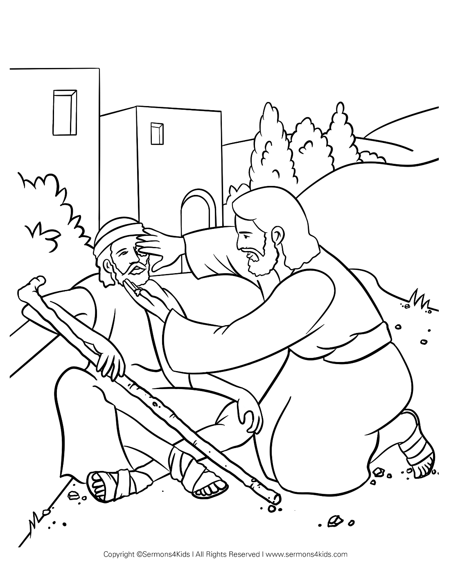

**Cambridge Causeway**

Spring 2025

Bible Study notes

**People changed by Jesus**

**5. The man born blind**

By Chrissy Cole